Edge in Solid Geometry
# Source: AI Source: Provided by: [Data Path: Persons Table -> ID Column: 1, Name_En Column: Motasem Essam] -> From: [ChatGPT] on [7/25/2026]
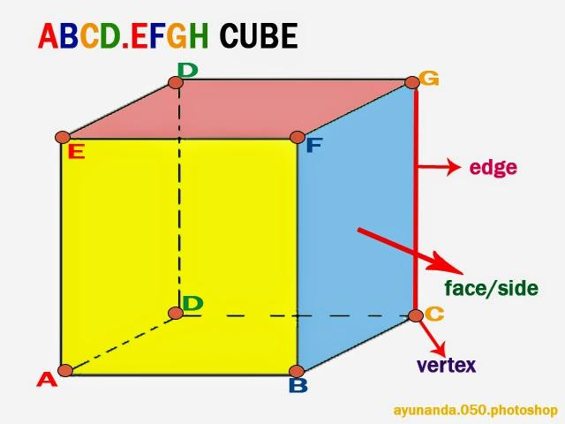
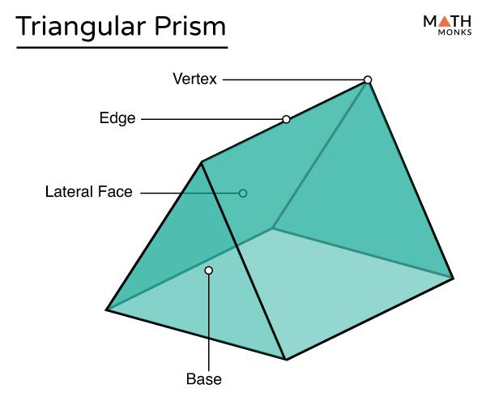
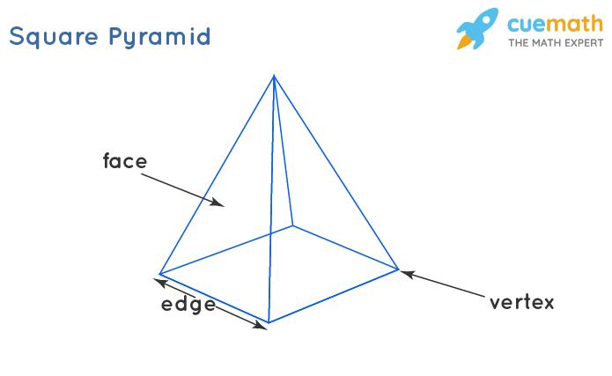

Definition
# Source: AI Source: Provided by: [Data Path: Persons Table -> ID Column: 1, Name_En Column: Motasem Essam] -> From: [ChatGPT] on [7/25/2026]
An edge in Solid Geometry is a boundary where two faces of a solid meet. In a polyhedron, an edge is a line segment joining two vertices and forming part of the boundary of the solid.
Edges connect vertices and define the boundaries of polygonal faces.

Simple Definition
# Source: AI Source: Provided by: [Data Path: Persons Table -> ID Column: 1, Name_En Column: Motasem Essam] -> From: [ChatGPT] on [7/25/2026]
An edge is a line segment forming a corner boundary between two faces of a solid.
For example, a cube has 12 edges. Each edge joins two of its 8 vertices and is shared by two square faces.

Key Characteristics
# Source: AI Source: Provided by: [Data Path: Persons Table -> ID Column: 1, Name_En Column: Motasem Essam] -> From: [ChatGPT] on [7/25/2026]
- One-dimensional: A straight edge has length but no width or area.
- Finite length: A polyhedral edge is a line segment with two endpoints.
- Connects vertices: Each polyhedral edge joins two vertices.
- Bounds faces: An edge is shared by two faces of a polyhedron.
- Measurable: Its length can be calculated or measured.
- Structural role: Edges help determine the shape and arrangement of a solid's faces.

Types of Edges in Solid Geometry

1. Base Edge
# Source: AI Source: Provided by: [Data Path: Persons Table -> ID Column: 1, Name_En Column: Motasem Essam] -> From: [ChatGPT] on [7/25/2026]
An edge belonging to the base of a solid.
Example: The four edges of the square base of a square pyramid.
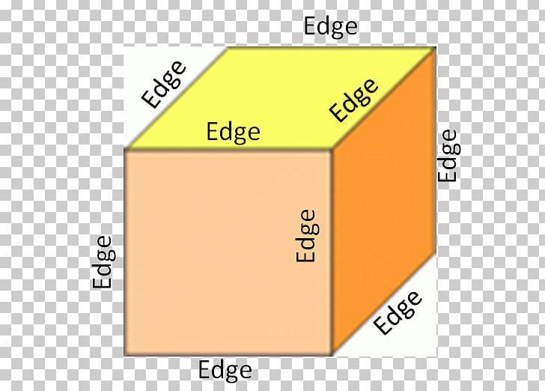

2. Lateral Edge
# Source: AI Source: Provided by: [Data Path: Persons Table -> ID Column: 1, Name_En Column: Motasem Essam] -> From: [ChatGPT] on [7/25/2026]
An edge connecting corresponding vertices of the two bases of a prism, or connecting a base vertex to the apex of a pyramid.
Example: A vertical edge of a right prism.
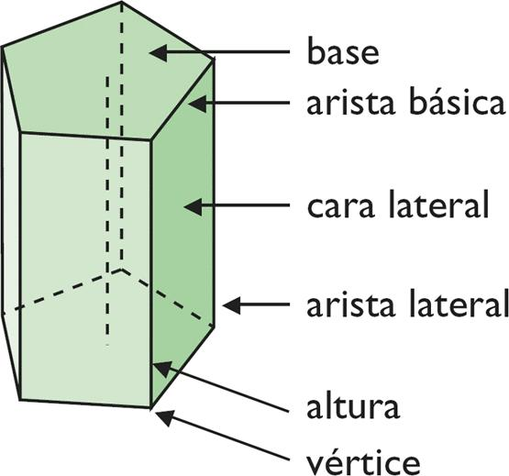

3. Straight Edge
# Source: AI Source: Provided by: [Data Path: Persons Table -> ID Column: 1, Name_En Column: Motasem Essam] -> From: [ChatGPT] on [7/25/2026]
A straight line segment forming the boundary between two flat faces.
Example: Any edge of a cube or cuboid.
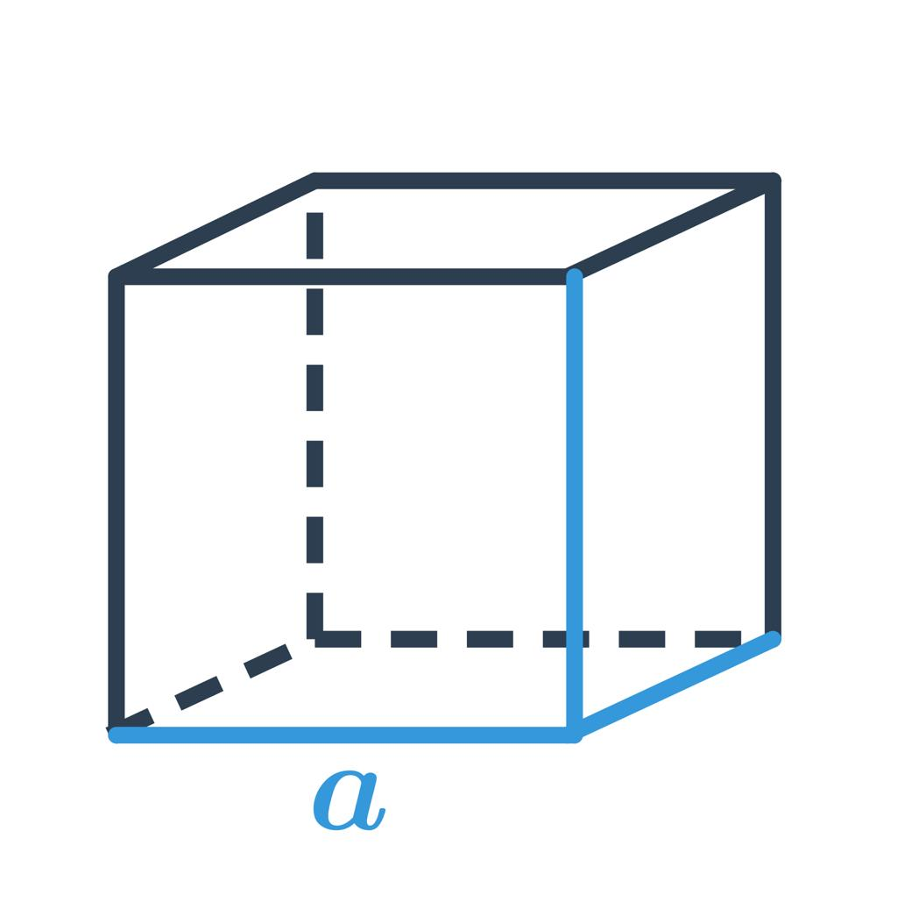

4. Curved Boundary
# Source: AI Source: Provided by: [Data Path: Persons Table -> ID Column: 1, Name_En Column: Motasem Essam] -> From: [ChatGPT] on [7/25/2026]
A curved line may form the boundary between a curved surface and a flat face. It is sometimes informally called a curved edge, but it is not a straight polyhedral edge.
Examples: The circular rim of a cylinder or cone.
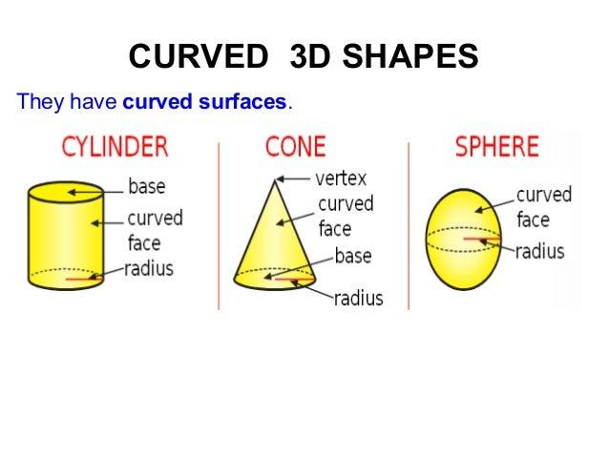

Number of Edges in Common Solids
# Source: AI Source: Provided by: [Data Path: Persons Table -> ID Column: 1, Name_En Column: Motasem Essam] -> From: [ChatGPT] on [7/25/2026]
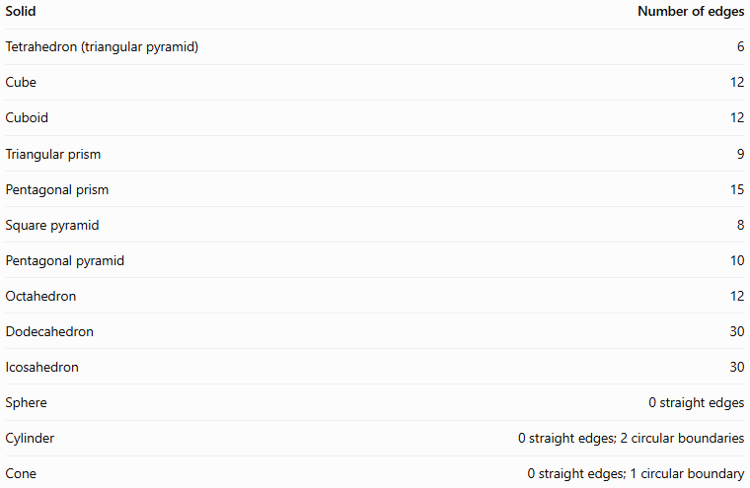
Solid | Number of edges
Tetrahedron (triangular pyramid) | 6
Cube | 12
Cuboid | 12
Triangular prism | 9
Pentagonal prism | 15
Square pyramid | 8
Pentagonal pyramid | 10
Octahedron | 12
Dodecahedron | 30
Icosahedron | 30
Sphere | 0 straight edges
Cylinder | 0 straight edges; 2 circular boundaries
Cone | 0 straight edges; 1 circular boundary
Important distinction: In standard polyhedral geometry, an edge is a straight segment. For curved solids, circular rims are often called curved edges in elementary descriptions, but they are more precisely described as circular boundaries.

Fundamental Properties

1. Edge Length
# Source: AI Source: Provided by: [Data Path: Persons Table -> ID Column: 1, Name_En Column: Motasem Essam] -> From: [ChatGPT] on [7/25/2026]
The length of an edge is the distance between its two endpoints.
For a cube with side length $a$, every edge has length
$$\boxed{L=a}$$
A cube has 12 equal edges, so its total edge length is
$$\boxed{L_{\text{total}}=12a}$$
For a cuboid with length $l$, width $w$, and height $h$, the total length of all 12 edges is
$$\boxed{L_{\text{total}}=4\left(l+w+h\right)}$$

2. Edges and Vertices
# Source: AI Source: Provided by: [Data Path: Persons Table -> ID Column: 1, Name_En Column: Motasem Essam] -> From: [ChatGPT] on [7/25/2026]
Every edge of a polyhedron joins two vertices.
For example, the 12 edges of a cube connect its 8 vertices. A vertex may be shared by several edges.

3. Edges and Faces
# Source: AI Source: Provided by: [Data Path: Persons Table -> ID Column: 1, Name_En Column: Motasem Essam] -> From: [ChatGPT] on [7/25/2026]
Each edge of a convex polyhedron belongs to exactly two faces.
For example, each edge of a cube is shared by two square faces.

4. Euler's Formula
# Source: AI Source: Provided by: [Data Path: Persons Table -> ID Column: 1, Name_En Column: Motasem Essam] -> From: [ChatGPT] on [7/25/2026]
For a convex polyhedron,
$$\boxed{V-E+F=2}$$
where:
- $V$ = number of vertices
- $E$ = number of edges
- $F$ = number of faces
Rearranging gives
$$\boxed{E=V+F-2}$$
For a cube, $V=8$ and $F=6$, so
$$E=8+6-2=\boxed{12}$$
This formula is useful for finding the number of edges when the numbers of vertices and faces are known.

Edge Length in Three-Dimensional Coordinates
# Source: AI Source: Provided by: [Data Path: Persons Table -> ID Column: 1, Name_En Column: Motasem Essam] -> From: [ChatGPT] on [7/25/2026]
If an edge connects two vertices $A=\left(x_{1},y_{1},z_{1}\right)$ and $B=\left(x_{2},y_{2},z_{2}\right)$, its length is calculated using the three-dimensional distance formula:
$$\boxed{AB=\sqrt{{\left(x_{2}-x_{1}\right)}^{2}+{\left(y_{2}-y_{1}\right)}^{2}+{\left(z_{2}-z_{1}\right)}^{2}}}$$
For example, if $A=\left(0,0,0\right)$ and $B=\left(3,4,0\right)$, then
$$AB=\sqrt{3^{2}+4^{2}+0^{2}}=5$$
Therefore, the edge length is $5$ units.

Edge vs. Vertex vs. Face
# Source: AI Source: Provided by: [Data Path: Persons Table -> ID Column: 1, Name_En Column: Motasem Essam] -> From: [ChatGPT] on [7/25/2026]
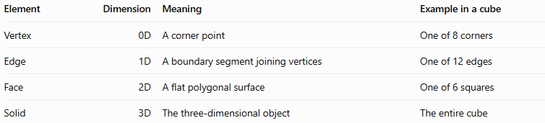
Element | Dimension | Meaning | Example in a cube
Vertex | 0D | A corner point | One of 8 corners
Edge | 1D | A boundary segment joining vertices | One of 12 edges
Face | 2D | A flat polygonal surface | One of 6 squares
Solid | 3D | The three-dimensional object | The entire cube

Applications
# Source: AI Source: Provided by: [Data Path: Persons Table -> ID Column: 1, Name_En Column: Motasem Essam] -> From: [ChatGPT] on [7/25/2026]
- Geometry: Counting and classifying the components of polyhedra.
- Architecture: Describing the boundaries and framework of structures.
- Engineering: Measuring lengths and designing solid components.
- Computer graphics: Connecting vertices to construct 3D mesh models.
- Mathematics: Applying Euler's formula to polyhedra.
- Manufacturing: Identifying boundaries and junctions between surfaces.

Key Points
# Source: AI Source: Provided by: [Data Path: Persons Table -> ID Column: 1, Name_En Column: Motasem Essam] -> From: [ChatGPT] on [7/25/2026]
- An edge is a one-dimensional boundary element.
- A polyhedral edge is a straight line segment joining two vertices.
- Each edge of a convex polyhedron is shared by two faces.
- A cube has 12 edges, while a triangular prism has 9.
- Euler's formula relates the numbers of vertices, edges, and faces.
- Curved solids may have circular boundaries, which should be distinguished from straight polyhedral edges.

Conclusion
# Source: AI Source: Provided by: [Data Path: Persons Table -> ID Column: 1, Name_En Column: Motasem Essam] -> From: [ChatGPT] on [7/25/2026]
An edge in Solid Geometry is a fundamental element that connects vertices and forms the boundaries between faces. Edges help define the structure of polyhedra, determine their dimensions, and support calculations involving lengths and geometric properties. Understanding edges, together with vertices and faces, provides the foundation for analyzing and constructing three-dimensional shapes.

